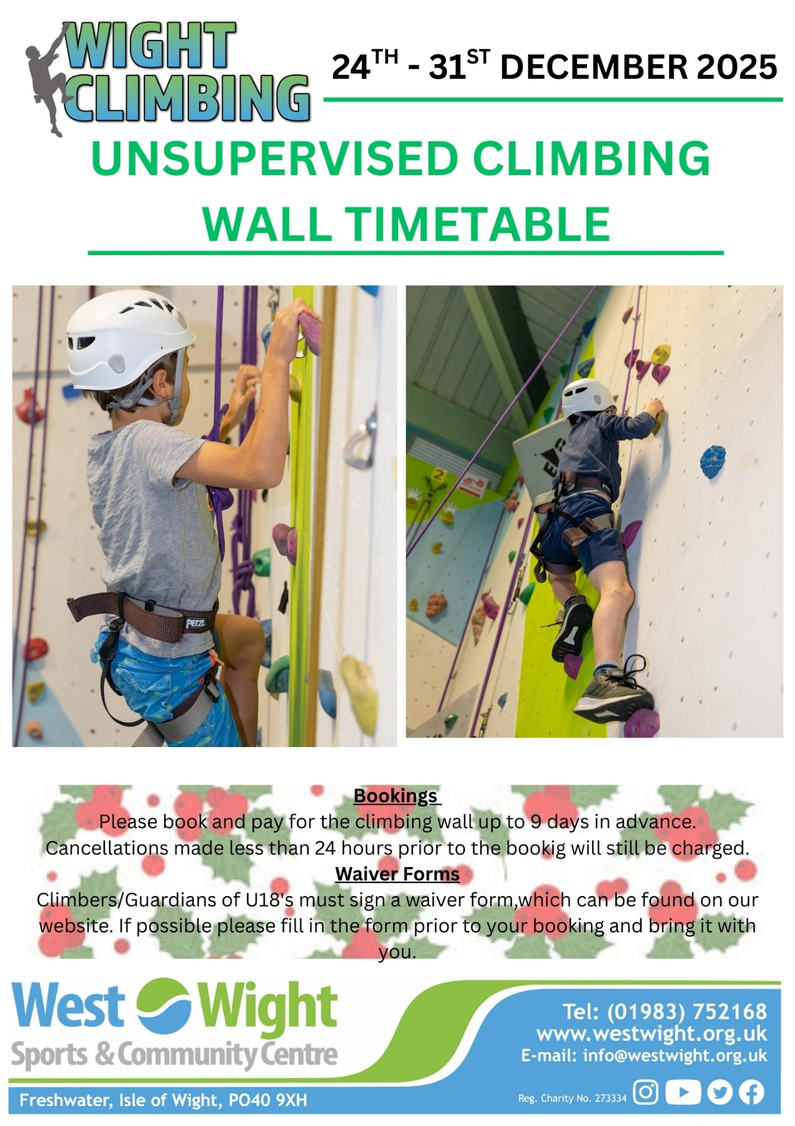
WIGHT CLIMBING We have the only indoor climbing wall on the Island which offers 7 climbing lines, we have routes for both beginners and experienced climbers, as well as a traversing wall. The routes are set monthly and we welcome climber feedback on these to ensure the wall stays fresh and exciting. Our wall is 6 to 7 metres in height and offers top rope climbing and lead climbing. We have a range of sessions available including instructor led sessions for children and adults and private hire for independent climbers. We also welcome group bookings.

Unsupervised Climbing Prices (Unsupervised sessions can be booked up to 9 days in advance) Climbing Wall Hire - £9 per person per hour
Private Climbing Tuition Prices (1.5 Hour Session) (Please give as much notice as possible for private climbing tuition) 5 people - £112.35 4 people - £89.90 3 people - £73.00 2 people - £56.20 Private Climbing Tuition Prices (1 Hour Session) 1 person - £28.10

Equipment Hire Prices (Unsupervised ONLY) Helmet – FREE Belay Set - £2.50 Harness and Belay Set - £3.50 Harness - £2.50



Unsupervised Climbing Wall Opening Times – 24TH – 31ST December 2025

