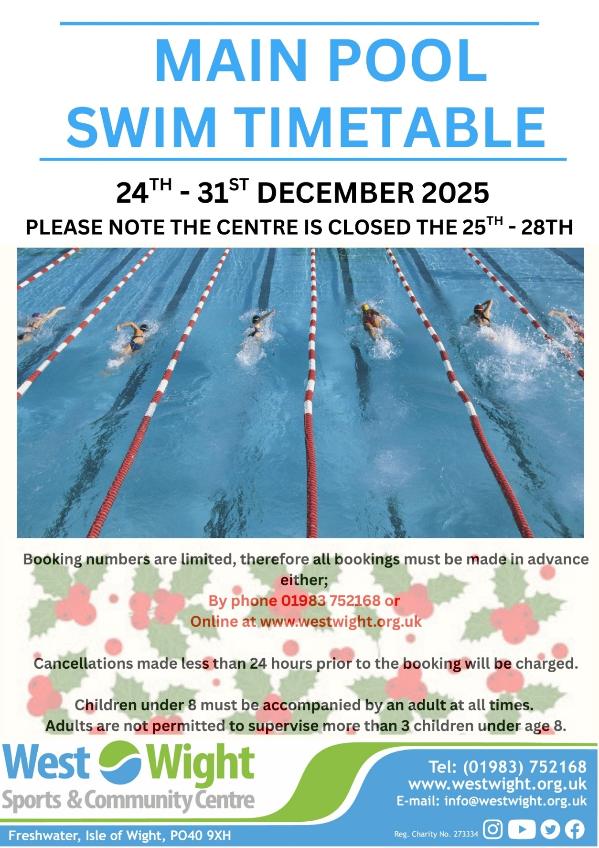
Pay-as-you-go Charges Fun Hour
Adult Swim £6.50 Adults/Under 20’s £4.50
Under 20’s £3 Under 4’s FREE
Under 4’s FREE
Please note you must be registered before booking online – this can be done with our reception team.

Adut swim lessons
Beginners – Non-swimmers or those that are nervous
Improvers – Comfortable in the water and able to swim 10m unaided
Adult swim fitness
A designated session for adults under the guidance of a qualified coach. Must be comfortable swimming 100m

Lane Swimming
Suitable for all ages and abilities – gentle, steady and speedy lanes
Open Swim Fun hour
A session with diving boards and no A session with mats across both
lane ropes, across both pools. pools.
Special care
Please see our website for more details.
Available for hire
Please enquire at reception to learn more.
Memberships
Swimming is included in Swim single/Couple and Diamond Plus memberships, please enquire at reception for more details.
Lane Swimming
9.00 – 12.00
Lane Swimming
7.00 – 11.00
Lane Swimming
9.00 – 13.00
Open Swim 14.00-15.00
Aqua Aerobics
11.00 – 12.00
Aqua Aerobics
12.00 – 13.00
Special Care
12.00 – 13.30
C L O S E D
Open Swim
13.00 -15.00
Open Swim
13.00 – 15.00

C L O S E D

C L O S E D

C L O S E D

